18793 HW8

Hongyi Zhou

1.

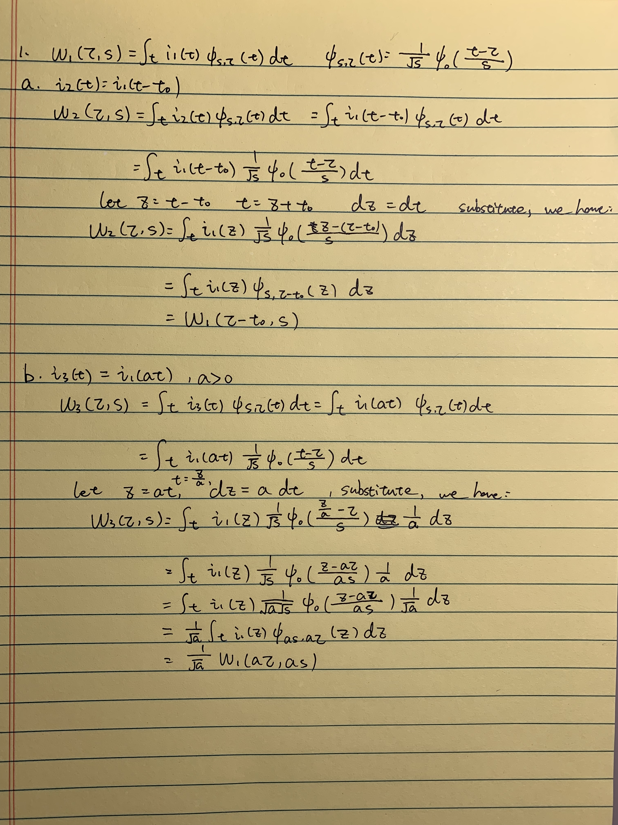

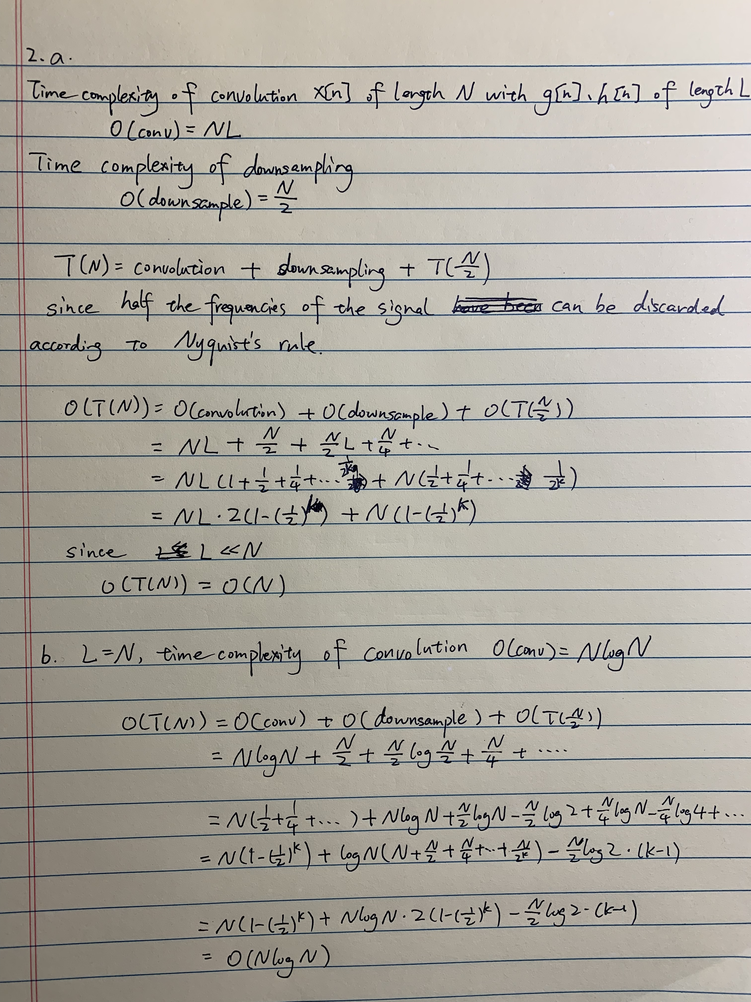2.

3

a.

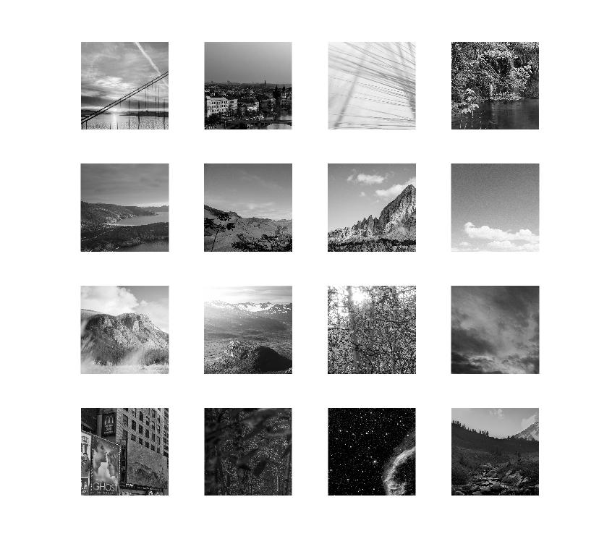

b.

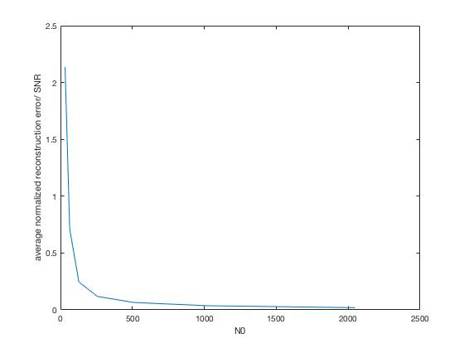

As the resolution of the image increases, the signal to noise ratio/ average

normalized reconstruction error decreases. This is because, as we increase the size of down-sampled image, we are able to capture more information and details, such as localized change in intensity, shape edges, etc. As a result, even though we keep the fraction of wavelet coefficients used constant, the reconstructed image is more similar to the original image.

c.

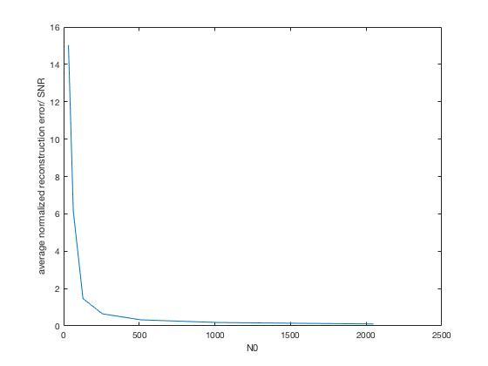

Compared with result in b, the average normalized reconstruction error for smaller fraction of wavelet coefficients is smaller. This is intuitive because, we use less wavelet functions to reconstruct the image and the result will be less accurate. In other words, the reconstruction accuracy increases as we uses more wavelet coefficients.

Code：

clear

close all

%% Load image

targetSize = [2048 2048];

Kfrac = 0.01;

ss = [32, 64, 128, 256, 512, 1024, 2048];

error = zeros(16,length(ss));

for i = 1:16

img = imread(sprintf('%01d.jpg', i));

img = rgb2gray(img);

img = double(img)/255;

%[x,y,w,h] = center(size(img),targetSize);

I = imcrop(img,[1,1,targetSize(1)-1,targetSize(2)-1]);

%processed(1,i) = I;

%subplot(4,4,i);

%imshow(I);

for j = 1:length(ss)

N0 = ss(j);

%downsample

I1 = imresize(I,[N0 N0]);

% figure;

% imshow(I1);

dwtmode("per");

[s0, cbook] = wavedec2(I1, log2(N0), 'db4');

s = abs(sort(s0, 'descend'));

K = int32(Kfrac\*N0\*N0);

shat = s(K);

s0(s0<shat & s0>-shat) = 0;

imghat = waverec2(s0, cbook, 'db4');

error(i,j) = norm(I1-imghat,2)/norm(I1,2);

disp(i)

disp(j)

end

end

err = sum(error);

figure;

plot(ss,err);

xlabel('N0')

ylabel('average normalized reconstruction error/ SNR')

function [x, y, w, h] = center(a,b)

x = int16(a(1)/2 - b(1)/2);

y = int16(a(2)/2 - b(2)/2);

w = int16(b(1) - 1);

h = int16(b(2) - 1);

end

4. 4 hours + 2 office hours